Dustin Nguyen IS 218:

Sorry if some of the screenshots are different, I did not see that we had to screenshot each step until the end because the instruction was at the end of the document.

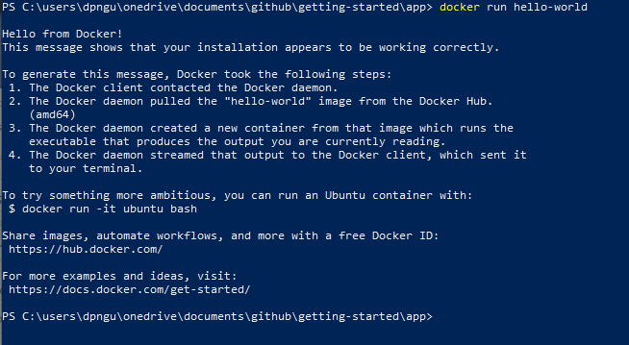Step 1:

Step 2:

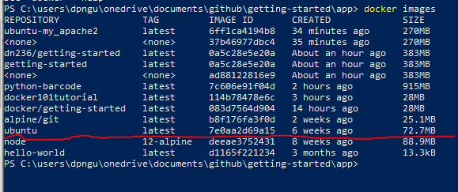

Step 3:

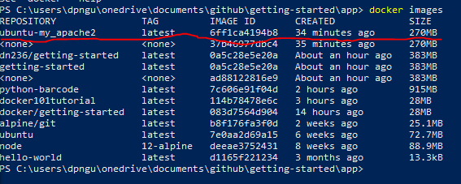

Step 4:

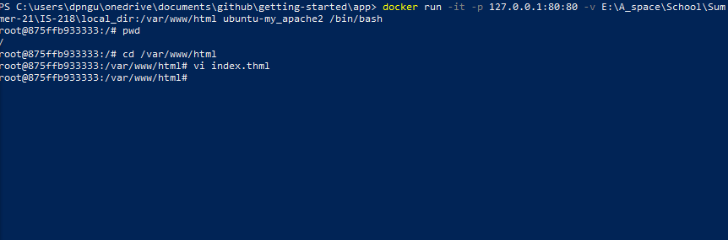Step 5:

Step 6:

